**Shubham P. Kumbhar**

**Wipro Assignments**

**Software Development Life Cycle**

--------------------------------------------------------------------------------------------

**Que 2. V-Model for E-Commerce :**

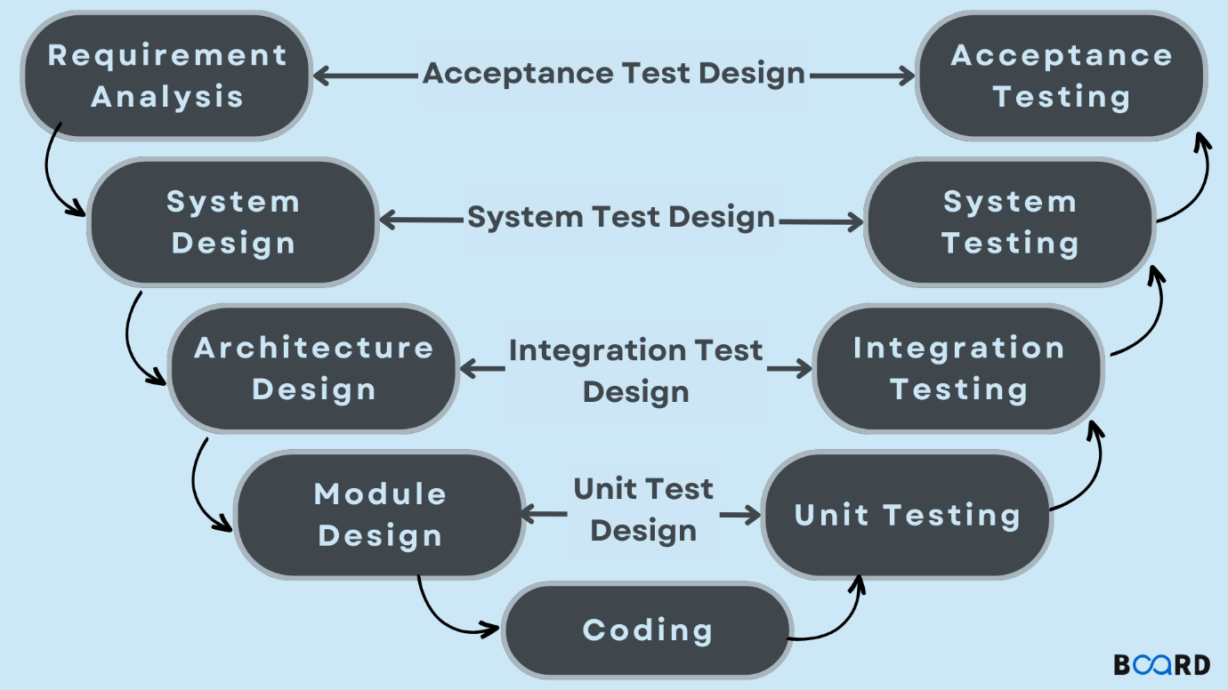

Here’s the detailed Software Development Life Cycle (SDLC) for the eCommerce application, formatted according to the specified V-Model steps:

**1. Requirement Analysis**

* **Objective**: Gather and document all the requirements for the eCommerce application.
* **Activities**:
  + Conduct stakeholder interviews and workshops to understand needs.
  + Document functional requirements (e.g., login, product display, sorting, cart, checkout).
  + Document non-functional requirements (e.g., performance, security).
  + Create use cases or user stories.
* **Deliverables**:
  + Requirements Specification Document
  + Use Cases/User Stories
  + Requirements Traceability Matrix

**2. System Design**

* **Objective**: Define the overall system architecture and high-level design.
* **Activities**:
  + Develop high-level system architecture diagrams.
  + Define system components and their interactions.
  + Plan for data flow, security, and integration points.
* **Deliverables**:
  + High-Level Design Document
  + System Architecture Diagrams
  + Security Plan

**3. Architecture Design**

* **Objective**: Create detailed architectural designs based on the system design.
* **Activities**:
  + Design detailed system architecture including server, database, and application structure.
  + Define how various components interact and communicate.
  + Specify protocols, technologies, and tools to be used.
* **Deliverables**:
  + Detailed Architecture Design Document
  + Component Interaction Diagrams
  + Technology Stack Specification

**4. Module Design**

* **Objective**: Design the detailed components or modules of the application.
* **Activities**:
  + Develop detailed designs for individual modules (e.g., user authentication, product management, cart).
  + Create UI/UX mockups and database schema.
  + Define data structures, algorithms, and interfaces for each module.
* **Deliverables**:
  + Module Design Documents
  + UI/UX Mockups
  + Database Schema

**5. Coding**

* **Objective**: Develop the application according to the design specifications.
* **Activities**:
  + Write and implement code for front-end and back-end components.
  + Develop and configure the database.
  + Ensure adherence to coding standards and best practices.
* **Deliverables**:
  + Source Code
  + Database Setup Scripts
  + Integrated Application Components

**6. Unit Testing**

* **Objective**: Test individual components or units of code to ensure they work as expected.
* **Activities**:
  + Create and execute unit tests for each module.
  + Validate that each component functions correctly in isolation.
* **Deliverables**:
  + Unit Test Cases
  + Unit Test Results
  + Bug Reports (if applicable)

**7. Integration Testing**

* **Objective**: Test the interactions between integrated components to ensure they work together.
* **Activities**:
  + Perform integration tests to check data flow and interaction between modules.
  + Validate interfaces and combined functionality.
* **Deliverables**:
  + Integration Test Cases
  + Integration Test Results
  + Integration Issues Report

**8. System Testing**

* **Objective**: Test the complete application to ensure it meets the specified requirements.
* **Activities**:
  + Conduct end-to-end system testing of the entire application.
  + Validate overall functionality, performance, and security.
* **Deliverables**:
  + System Test Cases
  + System Test Results
  + System Issues Report

**9. Acceptance Testing**

* **Objective**: Validate the application with end-users to ensure it meets their needs and expectations.
* **Activities**:
  + Conduct User Acceptance Testing (UAT) with actual users.
  + Gather feedback and validate that the application meets user requirements and usability standards.
* **Deliverables**:
  + UAT Test Cases
  + UAT Feedback
  + Acceptance Report

Each phase in this V-Model is linked to a corresponding validation phase to ensure that each aspect of the development process is thoroughly tested and verified. This approach helps in maintaining high quality and meeting the project requirements effectively.